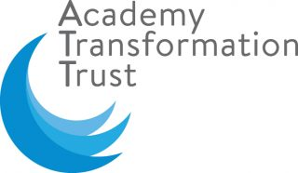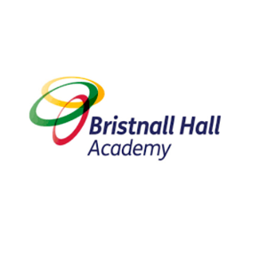

Bristnall Hall Academy
Remote Education Provision 2020/21

Remote education provision: information for parents
Introduction
This information is intended to provide clarity and transparency to pupils and parents or carers about what to expect from remote education if local restrictions require entire cohorts (or bubbles) to remain at home.
As both students and teachers become more experienced with remote learning we will continue to update this document.
For details of what to expect where individual pupils are self-isolating, please see the final section of this page.
The named contact who is responsible for the remote education offer at Bristnall Hall Academy is Mr Grainger, Assistant Principal.

The remote curriculum: what is taught to pupils at home

What should my child expect from immediate remote education in the first day or two of pupils being sent home?
If your child is sent home because they have been identified as a proximity contact of a positive case of Covid-19 within their bubble, the academy will set work for your child to complete on Microsoft Teams. Your child must log on by 8:45am each day and complete all work set for each lesson on their timetable. Where possible, staff will set up a live link to the lesson taking place within the academy so you child can join that remotely. Should you have any further queries, please contact us via email: attendance@bha.attrust.org.uk

Will my child be taught broadly the same curriculum as they would if they were in school?
We teach the same curriculum remotely as we do in school wherever possible and appropriate. However, we have needed to make some adaptations in some subjects or adjusted the order of topics where they can only be taught effectively in school. For example, completion of certain practical activities may need to be postponed until students return to the academy. Similarly, if a topic is particularly conceptually challenging, curriculum leaders again may move that to be taught at a time when students are back in the academy and can receive more 1:1 support. To ensure your child continues to make progress, please ensure your child engages with all lessons, tasks and activities on Microsoft Teams. The learning must continue.

Remote teaching and study time each day

How long can I expect work set by the school to take my child each day?
Students should be following their normal academy timetable online at home. Therefore, we expect that remote education (including remote teaching and independent activities set during lessons) will take pupils broadly the same amount of time as it takes students had they been in the academy. That is as follows:

Day | Lessons | Total Working time that day (excludes any homework set)
Monday | 3 x 1hr 50 min lessons | 5hr 30 min
Tuesday | 3 x 1hr 50 min lessons | 5hr 30 min
Wednesday | 2 x 1hr 50min lessons  1x 55 min lesson | 4hr 35min
Thursday | 3 x 1hr 50 min lessons | 5hr 30 min
Friday | 2 x 1hr 50min lessons  1x 55 min lesson | 4hr 35min

Accessing remote education

How will my child access any online remote education you are providing?
At Bristnall Hall Academy we use the online platform Microsoft Teams to deliver our remote education.
Students should be aware on how to log into the Microsoft Teams platform however, if they are not, please follow this guidance:
- Microsoft Teams can be accessed online at www.office.com or alternatively via the teams app:

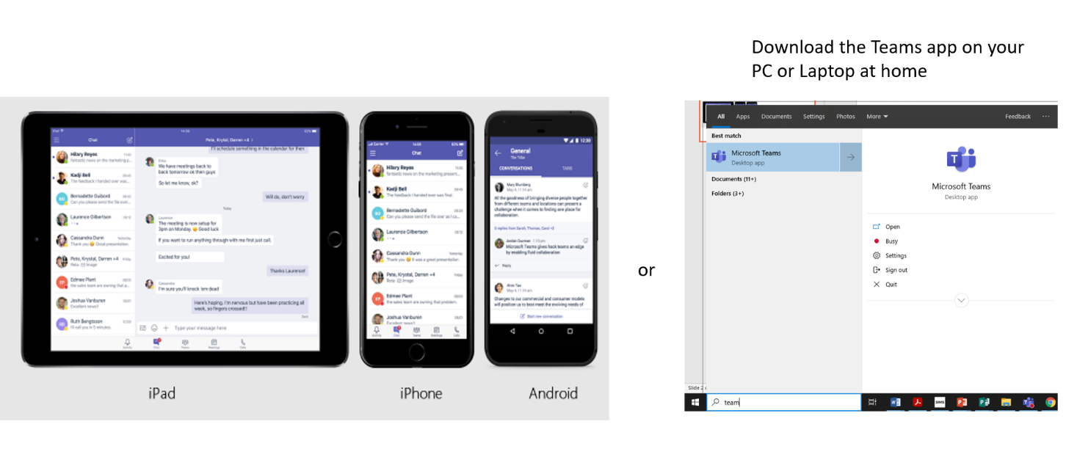

- Then log in to office365 or into the Teams app by following these steps:
- Open the Teams app or go to www.office.com
- Your sign in address is: YOURUSERNAME@bha.academy e.g. If my school username was AB1234 then my Teams login username would be: AB1234@bha.academy
- Your password is the same one you use to get onto the computers when in school.
If you are experiencing problems logging in or have any other technical issues then please contact: BHA-ITSUPPORT@bha.attrust.org.uk

If my child does not have digital or online access at home, how will you support them to access remote education?
We recognise that some pupils may not have suitable online access at home. This may be due to a number of reasons. Please be assured that we are here to support and it will be our priority to ensure there is as little disruption to your child’s learning as possible. Please refer to the table below to follow the action you should take in each scenario:
You do not have IT access at home (either because you don’t have a computer at home or you can’t use it as parents/siblings are using it).  You do not have internet at home | - Alert your achievement coordinator immediately by contacting the academy 0121 552 5425
You do not know your Office 365 password | - Email BHA-ITSupport@bha.attrust.org.uk or phone into the academy
Your do not understand the work set | - Ask your teacher for help on Teams or email your teacher who will respond either via email, telephone or through Teams  - If you are supported by the SEND Team – email them to ask for help  - Access the Oak National Academy: https://classroom.thenational.academy/ , find the lesson topic and watch that lesson whilst you wait for support from your teacher.
`You cannot remember your passwords | - Email BHA-ITSupport@bha.attrust.org.uk or phone into the academy

Where children do not have IT access or internet at home the academy will attempt to facilitate the following possibilities in order to support your child:
- The loaning out of IT equipment (e.g. Laptops/tablets etc.)
- The loaning out of internet equipment (e.g. 4G Hubs or dongles, additional 4G data allowance)
- The posting of or collection of a paper work pack which can be completed at home and then returned to the academy for teachers to mark.

How will my child be taught remotely?
Just as students would experience different styles of learning activity in the academy we feel it important that this is mirrored when learning online. Therefore, students will experience a range of online learning activities including, but not limited to:
- Listening to or watching their teacher deliver key knowledge online
- Taking part in Q&A both in the ‘chat’ function and verbally by unmuting their microphones
- Completing learning activities independently uploaded onto Teams
- Self-assessing their work
- Formal assessments
When teaching pupils remotely, staff will:
- set meaningful and ambitious work each day across your child’s lessons
- As a minimum, be available on the chat function in Microsoft Teams to support students with their learning
- provide teaching that is equivalent in length to the core teaching pupils would receive in school. This will include both recorded or live, direct teaching time and time for pupils to complete tasks and assignments independently.
- use a range of teaching methods including online live video lessons, recorded lessons (including supplementing teaching using lessons from the Oak National Academy) as well as encouraging students to work more independently at times but supporting remotely via the online chat function in Teams.
- provide opportunities for interactivity, including questioning, eliciting and reflective discussion
- provide timely and frequent feedback on how to progress often through activities in the lesson but also by using more formal methods of assessment where appropriate
- at KS4 provide scheduled subject specific Masterclass and further revision sessions throughout the remote learning period. These will be scheduled and the times communicated to students via their year group Teams channel.

In the case of staff absence, we will communicate this to students via their class channel and work will be set to be completed by students independently.

We place a huge importance on pastoral care. Therefore, in addition to their academic curriculum, students will have the opportunity to start every day with an assembly as well as finishing the day engaging in planned form time activities or partaking in a safe and well call with their form tutor. Numerous enrichment opportunities will also be made available including careers talks, guest speakers and virtual work experience to name just a few.

Engagement and feedback

What are your expectations for my child’s engagement and the support that we as parents and carers should provide at home?
We continue to have the same high expectations of students whilst learning remotely as we do when they are learning within the academy. For example, we expect students to:
- Arrive on time for lessons remotely following their normal academy timetable
- Contribute during the lesson and complete any work set to the best of their ability
- Conduct themselves appropriately just as they would when in the academy
- Demonstrate our Bristnall Hall Learner attributes by being adventurous, articulate, curious, creative, proud and resilient.

A number of educational experts have provided some of the steps children and parents can take to make the most of learning from home. Here are some tips on how to effectively study outside of the classroom:
- Take time away from your screen in your allocated breaks and lunchtime
- Communicate with your parents, carers and teachers if you are struggling
- Staying engaged will be hugely rewarding
- Create a routine
- Gets lots of sleep and rest
- Create a good learning environment if you can
- Utilise online learning resources where you can
The full article can be found here: How to make sure your child excels while learning from home | ITV News

How will you check whether my child is engaging with their work and how will I be informed if there are concerns?
At the beginning of each lesson, staff will monitor which students are online and engaging with the work set. A register is taken which is shared with our attendance team, achievement coordinators and senior leadership team.
We understand that remote learning can be a challenge for students and we are keen to recognise and reward the fantastic work and engagement from the majority of students. Students achievement and progress will be recognised on a daily basis through the award of ClassCharts points as well as positive postcards home and a number of other prizes for fantastic work and engagement.
Where we do have concerns with a student’s engagement, parents and carers will be contacted by the academy to investigate the reasons for non-engagement.
Where individual staff have concerns with the progress a student is making or with quality of work from a student, this will be fed back to the student in the first instance. Where concerns continue, again staff will raise their concerns with the achievement coordinator who then discuss further with the student, parents and carers.

How will you assess my child’s work and progress?
Feedback can take many forms and may not always mean extensive written comments for individual children. For example, whole-class feedback or quizzes marked automatically via digital platforms are also valid and effective methods, amongst many others. Feedback and assessment methods and frequency will be bespoke to individual subjects but may include:
- Extended pieces of writing that will be marked by the teacher and feedback provided online individually to students
- End of topic tests
- Whole class feedback
- Mini-plenaries and quizzes during the lesson that students will complete and then self-assess
- Online learning platforms to assess students such as Kahoot, Seneca Leaning, Corbett Maths, Hegarty Maths
We will await further guidance from the Department for Education on effective forms or formal assessment during times of remote education. If formal assessments are set to be completed remotely, it is important that your child completes these. Please contact your child’s teacher or achievement coordinator if for any reason they are unable to.

Additional support for pupils with particular needs

How will you work with me to help my child who needs additional support from adults at home to access remote education?
We recognise that some pupils, for example those with special educational needs and disabilities (SEND), may not be able to access remote education without support from adults at home. We acknowledge the difficulties this may place on families, and we will work with parents and carers to support those pupils in the following ways:
- Ensure that we are adapting resources so they are accessible to students with SEND
- Having support staff join online channels in Teams to offer additional support online
- Creating sub channels within a team where learning support staff can work with SEND students on a 1:1 basis.
- Ensuring there is frequent dialogue between our SEND team and families of SEND children.
- Ensuring literacy and numeracy interventions are continuing remotely

Our SEND team are available for additional guidance and support should you need it. Just contact the academy via email at infro@bha.attrust.org.uk or telephone 0121 552 5425. Our SENCO, Deputy SENCO and Level 3 SEND team will also make regular contact with both the students and parents of SEND students.

Remote education for self-isolating pupils
Where individual pupils need to self-isolate but the majority of their peer group remains in school, how remote education is provided will differ slightly from the scenario where all children are learning at home. This is because teachers will be delivering lessons to students in the academy.
Where a student is self-isolating, they should still log into Microsoft Teams and follow their normal timetable. The lesson resources will be uploaded by the member of staff to ensure that the student who is at home isolating has access to the same curriculum that is taking place in school.
Where technology allows, staff delivering lessons in school will set up cameras/microphones so that students at home can listen in on the lesson.

