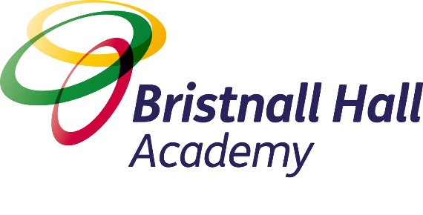

The Bristnall Hall Academy Way

September 2020

Guidance for All Colleagues

Vision Statement

We have one core purpose:
To have the biggest positive impact in the varied communities we serve through ensuring top drawer education for our learners. #TransformingLives
How do we ensure this across our trust?
In all we do we are:
1. Ethical to the core, ensuring that education is always front and centre
2. Futures focused system leaders – never simply followers
3. Collaborative in every endeavour
4. Resolutely learner centred.
What does this look like across our trust?
Education
We are:
1. Ruthlessly ambitious for all who learn and work with us
2. Unwaveringly inclusive – determined on eradicating barriers to educational success
3. Committed to excellent teaching
4. Determined upon academic excellence for all in our communities
5. Compassionate, ethical and caring advocates for all in our communities
6. Outwardly facing and globally conscious
Operations
We are:
1. Committed to the very best people development and empowerment
2. Determined to shout loudly and share proudly our successes
3. The best professional and technical experts (supporting education) in the sector
4. Committed to the very best understanding and management of risk
Financial
We are:
1. Providing the best possible public service for the best possible value
2. Determined to supplement our public income with shrewd income generation
3. Building financially sustainable models of educational improvement in our communities
4. Demonstrably efficient in all we do
Our Strategic Aims, 2018-2021
Aim 1: By August 2021 we will be regarded as one of the top 10 performing MATs for both primary and secondary academies in the DfE and other reputable performance tables.
Aim 2: By August 2021 we will have fully embedded the ‘Education CSI’ model. This will clearly define the capacity and bespoke systems required for each individual academy.
Aim 3: By August 2021 our finances will be fully balanced, with a healthy Trust surplus and a clear plan of action to build up central reserves to an acceptable level; thus providing sustainable financial capacity. ATT will be regarded as a beacon of excellent practice by NGA, ISBL and the ESFA.
AIM 4: By August 2021 we will have carefully grown in our two main regions and will be regarded as a System Leader Trust (30+), providing more capacity and alleviating the individual financial responsibility of each academy.
Aim 5: By August 2021 we would have embedded rigorous Performance Management standards for leaders at every level, developing the individual capacity of academies and the Trust as a whole.
Aim 6: By August 2021 we will have completed a process of alignment across our academies to ensure tight practices and protocols are standardised against agreed practices of excellence.
Aim 7: By August 2021 we will have created and embedded a Talent Management Process across the organisation, ensuring a complete strategic understanding of acquisition and retention requirements. CPD will be aligned accordingly to strengthen leadership capacity at all levels.
Aim 8: By August 2021 we will insist that every pupil experiences a variety of opportunities through a cultural capital passport - ‘ATT Enrichment Passport’ - that will run in parallel with their education journey.
Aim 9: By August 2021 100% of academies, that have been with the Trust for more than 3 years, will be judged as good or better by Ofsted.
Aim 10: By August 2021 each academy would have initiated an individual community engagement action plan. The plan will place each academy at the heart of its community, enabling the academy to become not only a hub for learning, but a community resource for lifelong learning.

Managing Pupil Behaviour
All adults at the academy are responsible for managing pupil behaviour.

We believe that in order for our student/learners to achieve their maximum potential, and to enable effective teaching and learning to take place, the highest standard of behaviour in all aspects of academy life is essential. Each member of staff has responsibility for upholding standards of behaviour in our academies, both within their classroom, around our academy sites and whilst supervising student outside of our academies, as well as implementing our behaviour policy both fairly and consistently
We believe that children and young people’s behaviour and attitudes is intrinsically linked to their success in learning. We focus on developing and promoting positive attitudes and behaviours through high quality teaching, a stimulating learning environment and a culture of praise, recognition and self-discipline. All combine to lead to a rich climate for learning.
We believe that teachers manage pupil behaviour most effectively when they are warm but strict. They encourage student to be independent while maintaining limits and controls on their actions. Authoritative teachers do not invoke the ‘because I said’ rule; instead they are willing to listen to and take into account the pupil’s viewpoint. Authoritative teachers engage in discussions and debates with the pupil although ultimate responsibility lies with the teacher. In this way, student learn how to negotiate and engage in discussion. They understand that their opinions are valued. It is through consistently applying a warm/strict philosophy to behaviour management that student are more likely to become socially competent, responsible and autonomous.
Our expected standards of behaviour are clearly communicated to student, staff and parents in the relevant sections of this document, The ‘Bristnall Hall Academy Way’.

Relationships
“Friendly, not friends”

Getting to know the student at the academy is a vital part of our job. Building strong relationships means student trust us with their education. Take the approach of ‘friendly, not friends’.
Student should always refer to staff by their surname or ‘Sir/Miss’ and ensure they know where the boundaries in the pupil/ teacher relationship are. Learn about your student but ensure that they know their education is your utmost priority.
Rewarding positive pupil behaviour is one of the most important aspects of our work.
At Bristnall Hall Academy we ensure that all positive behaviour are rewarded including, students manners, work and attendance.
We use class charts to reward behaviour as points increase so does the reward:
- 150 points Bronze
- 300 points Silber
- 450 points Gold
- 600 points Platinum
There are weekly and half termly rewards for excellent attendance including each half term the ’25 days challenge
Consistency
“We become what we want to be by consistently being what we want to become each day” - Richard G. Scott

It doesn’t matter what we do, it matters that we all do it. If you allow student to listen to their headphones, then the next member of staff who challenges this will seem unreasonable.
Student will be confused why they can do it in one classroom and not another.
They will challenge the teacher who upholds the academy expectations, and this may damage their relationship with that pupil.
Being inconsistent undermines our culture and shows student that some adults do not care as much as others. This in turn creates a perception with student that some adults are more important than others.
It is therefore critical that we apply sanctions in a consistent way.
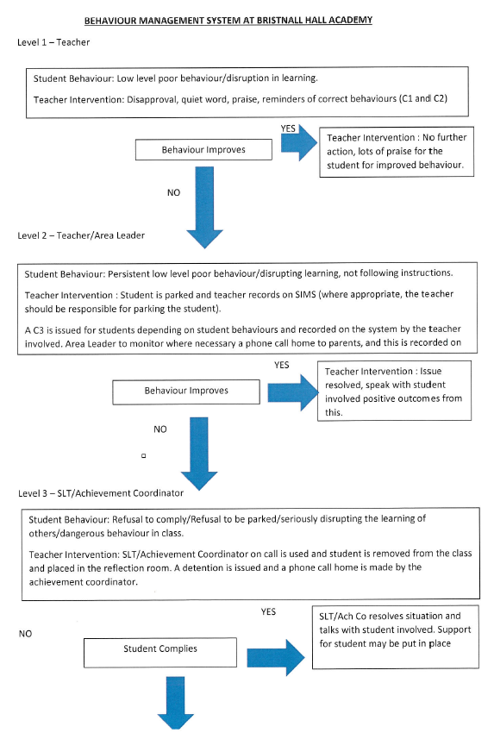
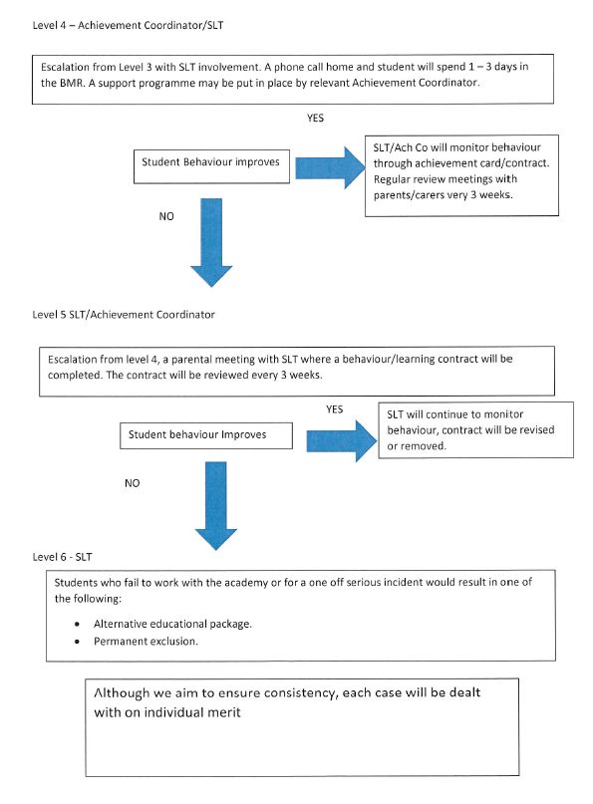

Expectations of Conduct in Lessons
Teacher will greet the class from the door. All students will enter the classroom in a controlled manner, in full uniform with coats off. They will sit in their designated seat, get their equipment (Passport for Learning) out on the table (planner, pencil case) ready to learn. There will ‘always’ be a set task given to the students so learning can take place immediately. The lessons feature the learning wheel, indicating, which part if lesson the student are in.
There are no bells at Bristnall Hall Academy, so all students will work until told to pack away by their teacher. Equipment will be collected in, in an orderly manner. All students will wait for instructions to leave the classroom. When told, students will stand behind their chairs and will leave the classroom in a quiet and calm manner and follow the one-way system when it applies. All staff are at the doors of the classroom to ensure students movement in the corridors is always safe and controlled.
In lessons, our Learning Wheels indicate to the students the type of activity they are involved in:

Students adhere to ‘The Bristnall Basics’, our expectation of every student in the Academy:
- Here every day
- Always on time
- Properly dressed and equipped
- Polite and kind
- Respectful and inclusive
Our learner dispositions are derived from the Growth Mindset model:
- Adventurous
- Curious
- Resilient
- Proud
- Articulate
- Creative

Our teaching and support professionals are committed to continuous improvement in the four pedagogical fundamentals:
- Subject knowledge scholarship and expertise
- Contextualising, explaining, scaffolding and modelling
- Questioning and feedback
- Retrieval practice and fluency
These strands not only shape our People Development offer but are underpinned by our incremental coaching model.

Expectations of Conduct Around the Academy
“The standards you walk past are the standards you accept” - David Hurley
Students in Year 7, 8 and 9 line up in form groups at the start of day, end of break and lunch. Students when directed walk to their classrooms in their lines and met at classrooms by their teacher. Students in Year 10 and 11 walks to their classroom when they are met by their teacher.
Students will remove coats on entering the building, coats should not be worn inside the academy site.
Students will be respectful of each others learning environments when moving to and from lessons.
All lessons are ‘double lessons’ so at the end of lessons they exit the room under the direction of their teacher and exit building into their designated outside zone space.
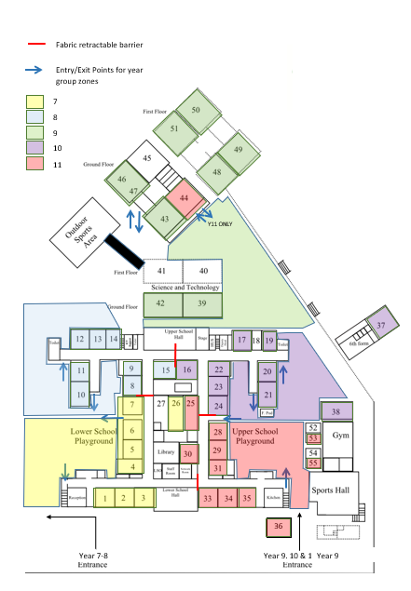

Pastoral Responsibility
The Pastoral Support team is made up of an Assistant Principal (Behaviour), Assistant Principal (Safeguarding), Attendance Officers, Achievement Coordinators, LSU Manager and BMR Manager. This team has an important role in support students to ensure they achieve whatever difficult circumstances that may arise.
Each year group has an Achievement Coordinator (who has a non-teaching commitment), thus allowing them to support our students directly, throughout the day.
Year 7: Miss C Brzosko Year 8: Mr C Brooks
Year 9: Mr J Neadle Year 10: Miss N Lambert
Year 11: Miss S Samuels

BMR Manager EAL Coordinator LSU Coordinator

Collaborative working between professionals and services enhances the outstanding provision of care available to our young people. Professional partners include: Sandwell Children’s Services, Inclusion Support, School Nursing Team, Community Police Officers, Prevent team, Sandwell PSHE lead, Albion Foundation Trust, Kooth, Careers and Enterprise Company and Connexions.
Duty Protocol
Duties are an essential part of our role in keeping children safe and ensuring that positive relationships are fostered.
SLT are on duty before and after schools and during break and lunchtimes. They are given specific areas of the academy to look after to ensure our students are safeguarded and positive relationships are fostered.
All teaching staff are required to complete two break-time (40 minutes) duties per week in a designated zone.
At changeover of lessons all staff are responsible for the safe movement of students around the academy. SLT have designated zones to manage.
At the start and end of the day SLT and ELT are present at the gates of the academy to welcome students.

Bristnall Hall Academy Duty List Template
Duty Area | MONDAY | TUESDAY | WEDNESDAY | THURSDAY | FRIDAY
Lower Gate AM
Upper Gate AM
P 1 LSP entrance to LSU/ lockers
P 2 LSP, doors by R 6 & 7
P 3 LSB toilet entrance at end of each duty
P 4 Field / back of a college/ tech block
P 5 USP middle area
P 6 USP mobiles/gym
P 7 reception / LSG toilets corridor 1 to 3
P 8 LSB toilets Corridor 12 to 15 / 11 & 10
P 9 USB toilets corridor R 19 to 16 , 20 & 21
P 10 USG toilets corridor 35 to 33 / Kitchen entrance
Break Time Cover
YEAR 9/10/11 Zone
Break Time Cover
YEAR 7/8 Zone
Lunch time Cover
YEAR 9/10/11 Zone
Lunch time Cover
YEAR 7/8 Zone
Lower Gate Duty PM

Upper Gate Duty PM
QUEENS ROAD

BRISTNALL HALL ROAD

Leading by Example
“Setting an example is not the main means of influencing others, it is the only means” (Albert Einstein)
Our “Academy Way” outlines the ways in which we put our values into practice with the aim to engender and foster exemplary behaviours which enables our people to be the very best role models for our learners.
“Being a role model is the most powerful form of educating. Youngsters need good models more than they need critics” (John Wooden)

We are unwavering in our commitment to put our people first and in our endeavours to do so our Institute was born! We make no secret of our expectation that all colleagues must be “accepting of the professional obligation to improve their practice” (Tomsett et al 2020). Our Institute offers a wide range of people development activities and career pathways designed to support our colleagues in their professional obligation and to be the best role models for our learners.

“The Bristnall Hall Academy Way” Professional Code
The purpose of this policy document is to set out clear expectations of conduct for all staff (whether permanent, temporary, voluntary, or on placement) of` the academy.

This document should contribute to the safety and well being of staff and students. It should clarify what is and what is not acceptable.

Academy staff have legal obligations in relation to the safeguarding of children.

Academy staff are in a unique position to set examples of behaviour which can influence and be copied by students. Staff should therefore demonstrate high standards of conduct in order to encourage students to do the same.

Employees should have regard for the impact of their personal behaviour on all aspects of our community. Appropriate conduct helps to reinforce a positive image of the academy to the public, our clients and partner agencies.

Staff should conduct themselves with honesty, integrity and respect for fellow employees, students and the wider community.

Staff have a duty to express concerns about the actions of other members of staff who may be in breach of this guidance.

This policy does not stand alone and it is not exhaustive. It should be implemented in line with contractual obligations, other relevant academy policies (such as Child Protection, Anti-Bullying, Equal Opportunities, Complaints, Health and Safety, Whistle blowing, Social Media Policy etc.), government guidance, professional association guidance, Sandwell Council personnel procedures and the GTC Code of Conduct for Teachers. If staff are unclear about any aspect of this guidance they should seek further clarification.

All staff should be aware of the principles and expectations of this policy. Staff should be aware that a failure to comply with the Code of Conduct could result in disciplinary action including dismissal.

This Code of Conduct applies to:
- All staff who are employed by the academy, including the Principal
- All staff in units or bases that are attached to the academy.

This Code of Conduct does not apply to:
- Peripatetic staff who are centrally employed by the LA
- Academy catering staff employed by an external contractor
- Employers of external contractors and provider of services (e.g. contract cleaners).

Such staff are covered by the relevant Code of Conduct of their employing body. However, we do expect these people to have regard for our Code of Conduct when working on our premises.

Setting an Example and Promoting an Inclusive Work and Learning Environment

All staff who work in the academy set examples of behaviour and conduct which can be copied by students. Therefore, all staff need to demonstrate high standards of conduct in order to encourage our students to do the same.

All staff must also avoid putting themselves at risk of allegations of abusive or unprofessional conduct.

All staff must embrace and promote an inclusive work and learning environment where our differences are valued and respected and we treat each other with mutual respect and dignity.

Safeguarding Students

The 6 R’s
Receive
Listen to what is being said, without displaying shock or disbelief
Take what is said seriously
Note down what has been said.
Reassure
Reassure the pupil, as far as is possible
Don’t promise confidentiality, you have a duty to refer
Reassure and alleviate guilt
Reassure the child that information will only be shared with those who need to know.
React
React to the pupil only as far as is necessary for you to establish whether or not you need to refer this matter, but don’t ‘interrogate’ for full details
Do not ask ‘leading’ questions, for example, “Did he/she…, such questions may invalidate your evidence (and the child’s) in any later prosecution
Ask open questions, like “Anything else you would like to say?”
Do not criticise the perpetrator; the pupil may have an affection for him/her
Do not ask the pupil to repeat it all for another member of staff
Explain what you have to do next and who you have to talk to.
Record
Make some brief notes at the time on any paper, which comes to hand. Write notes up as ‘add incident’ on CPOMS as soon as possible and pass a copy to the Designated Safeguarding Lead
Do not destroy your original notes; attach these to the safeguarding form. Record the date, time, place, any noticeable non-verbal behaviour and the words used by the child. Record the actual words used by the child
Record statements and observable things, rather than your ‘interpretations’ or assumptions.
Remember
Follow your academy’s guidelines and consult as appropriate
Procedures require the Designated Teacher (staff) to make appropriate records to Social and Health Care.
Reflect
Try to get some support for yourself if you need it. This support should be available through your Designated Safeguarding Lead.

Staff have a duty to safeguard students from:

- Physical abuse
- Sexual abuse
- Emotional abuse
- Neglect
- Peer to Peer Abuse
- Terrorism and Radicalisation

It is important to note the offence under section 16 of The Sexual Offences Act 2003, which provides that it is an offence for a person aged 18 or over (e.g. teacher, youth worker) to have a sexual relationship with a child under 18 where that person is in a position of trust in respect of that child, even if the relationship is consensual. A situation where a person is in a position of trust could arise where the child is in full-time education and the person looks after children under 18 in the same establishment as the child, even if s/he does not teach the child.

The duty to safeguard students includes the duty to report concerns about a pupil to the academy’s Designated Safeguarding Lead for Child Protection of Safeguarding (DSL).

The academy’s Designated Safeguarding Lead/Deputy Designated Safeguarding Lead are Antoinette Jackson and Ian Jones.

Staff should familiarise themselves with ATT’s Safeguarding Policy, e-Safety Policy, the academy’s Child Protection Procedures and Whistleblowing Procedure, copies of these can be found on the academy learning platform. Staff must be able to carry out the duty as outlined in Keeping Children Safe in Education and Working Together to Safeguard Children. All staff should be aware of the ATT Health and Safety Policy.
Staff must not seriously demean or undermine students, students’ parents or carers, or colleagues (this includes online) and must take reasonable care of students under their supervision with the aim of ensuring their safety and welfare.

Standards of Behaviour

Underpinning Principals;
- The welfare of the child is paramount
- Staff should understand their responsibilities to safeguard and promote the welfare of students
- Staff are responsible for their own actions and behaviour and should avoid any conduct which would lead any reasonable person to question their motivation and intentions
- Staff should work, and be seen to work, in an open and transparent way
- Staff should acknowledge that deliberately invented or malicious allegations are extremely rare and that all concerns should be reported and recorded
- Staff should discuss and/or take advice promptly from their line manager if they have acted in a way which may give rise to concern
- Staff should apply the same professional standards regardless of culture, disability, gender, language, racial origin, religious belief and sexual orientation
- Staff must not consume or be under the influence of alcohol or any substance, including prescribed medication, which may affect their ability to care for children
- Staff should be aware that breaches of the law and other professional guidelines could result in disciplinary action being taken against them, criminal action and/or other proceedings including barring by the Disclosure & Barring Service (DBS) from working in regulated activity.
- Staff and managers should continually monitor and review practice to ensure this guidance is followed

Staff should not:
- behave in a manner which would lead any reasonable person to question their suitability to work with children or to act as an appropriate role model
- make, or encourage others to make sexual remarks to, or about, a pupil
- use inappropriate language to or in the presence of students
- discuss their personal or sexual relationships with or in the presence of students
- make (or encourage others to make) unprofessional personal comments which scapegoat, demean or humiliate, or might be interpreted as such

Staff should:
- be aware that behaviour by themselves, those with whom they share a household, or others in their personal lives, may impact on their work with children
- are expected to treat information they receive about students and families in a discreet and confidential manner
- Staff must maintain high standards of honesty and integrity in their work. This includes the handling and claiming of money and the use of academy property and facilities.

Appropriate Conduct with Students

Staff should establish and maintain appropriate professional boundaries in their relationships with students.

Staff must not engage with students on social networking sites or through personal electronic mail (use academy e-mail addresses) and messaging services.

Staff should use appropriate standards of language when engaging students.

Staff should be aware of guidance and law in relation to physical contact and restraint of students.

Staff who have contact with students in settings out of academy should maintain appropriate professional standards.

Staff should use appropriate channels to report concerns about students who challenge this boundary.

Staff should use appropriate channels to raise concerns about the conduct of other staff who may be putting themselves or students at risk in this regard.

Student performance, progress and interests

Staff must comply with academy policies and procedures that support the well-being, safety and development of students and must co-operate and collaborate with colleagues and with external agencies where necessary to support the development of students.

Staff must follow reasonable instructions that support the development and safety of students.

Staff should do their best to ensure the progress, development and wellbeing of students in their care.

Staff should comply with academy policies and procedures that support student progress and development.

Staff should report on students’ progress to parents in line with agreed procedures.
Staff should provide progress grade data in line with agreed procedures.

Staff should listen to children, uphold their rights, have high expectations of behaviour and progress and should support their confidence and self awareness.

Staff should co-operate and collaborate with other colleagues and agencies in this regard.

Equality of Opportunity

Staff should support the academy’s commitment to equality of opportunity which promotes inclusion and values diversity.

Staff should support the principle of showing respect to all, regardless of gender, race, ethnic background, culture, (dis)ability, sexual orientation, age, religion, socio-economic status or any other factor.

Staff should ensure that all are encouraged to perform to the best of their ability.

Harassment and Bullying

All staff, students and the wider community should be able to go about their business without fear of harassment, bullying or intimidation.

Staff should ensure that their own behaviour, whether intentional or unintentional, does not lead others to feel uncomfortable, threatened or harassed.

Staff should use appropriate channels to report such behaviour observed in other staff.

Staff should report and follow up all reports from students about bullying.

Health and Safety

The academy is committed to ensuring the health and safety of all students, staff and others. Staff should participate in training in relation to Health and Safety.

Staff should take all reasonable steps to ensure the safety of students in their care, themselves and others in line with the Health and Safety at Work Act and other legislation.

Staff should undertake appropriate risk assessments for all activities and visits in accordance with academy policies.

Staff should be aware of policy, guidance and requirements in relation to transporting students in staff vehicles.

Staff should exercise caution when driving on the academy site, should observe the 5 mph speed limit and adhere to the correct entry and exit on the car park. No vehicles should be moved from the rear of the site during the school day. Gates will open for emergency vehicles only. Therefore, do not park in front of the gates or double park anywhere on site. No staff cars should move before 10 minutes after the end of school in order to allow safe student exit from the premises.

Staff should use appropriate channels to report health and safety concerns.

Staff should use appropriate channels to report other staff, who adopt unsafe practices.

Cooperation with other professionals

Staff should maintain professional relationships with other staff within the academy and with staff in partner agencies.

Staff should cooperate with others, communicate appropriately, and share responsibilities as agreed.

Staff should ensure courteous, efficient and impartial service delivery to all individuals and groups.

Staff should cooperate with reasonable requests from other staff.

Appointment and Management of Staff

The academy is committed to the appointment, promotion and management of staff purely on the basis of merit. Selection, promotion or performance grading based on anything other than ability leaves the academy vulnerable to allegations of discrimination.

Staff should not therefore be involved in appointments or performance management of other staff with whom they have, or have had, a personal, emotional, marriage or family relationship.

Performance

All staff have a responsibility to maintain and develop the professional expertise relevant to their job role. This will ensure the quality and development of staff and will enhance the quality of service delivered.

Staff should participate in appropriate professional development.

Staff should participate in agreed performance management procedures.

Absence and Timekeeping

All staff should comply with agreed procedures for notifying absence and for applying for leave of absence.

All staff should maintain good timekeeping in line with agreed arrangements.

All staff should notify managers/colleagues if they need to go off site for meetings/visits etc. This should include their anticipated time of return.

Misuse of Drugs and Alcohol

Staff must ensure that they are not unfit for duty as a result of the effects of drugs or alcohol.

Staff should be aware of the lasting effects of alcohol and drugs both legal and illegal, and ensure that consumption of these substances does not impair their ability to discharge their duties. Staff should not consume alcohol during the school day.

Smoking/Vaping

The academy does not allow smoking or vaping anywhere on the premises. Staff must not therefore smoke or vape on the academy site at any time.

Staff should not smoke or vape off site where they can be seen by students. Students who see staff smoking or vaping may see this as an endorsement and may start to or continue to smoke or vape themselves.

Conduct outside Work

Staff must not engage in conduct outside work which could seriously damage the standing and reputation of the academy, or the reputation of the employee, or the reputation of other members of the academy community.

In particular, criminal offences that involve violence or possession or use of illegal drugs or sexual misconduct are likely to be regarded as unacceptable.

Staff should exercise caution when using information technology and be aware of the risks to themselves and others. Staff should adhere to ATT e-Safety and Social Media Policies. Staff should exercise caution when posting personal information, comments or photographs on networking sites and should be aware that anything shared on the web could potentially be accessed by students. Staff should not communicate with students on social networking sites. Staff should not share personal emails or personal email addresses with students. Any comments posted online by staff must not bring themselves or the name of the academy into disrepute.

Staff may undertake work outside the academy, either paid or voluntary, provided that it does not conflict with the interests of the academy nor be to a level which may contravene the working time regulations or affect an individual’s work performance.

Staff must not engage in conduct outside work which could seriously damage the standing and reputation of the academy, or the reputation of the employee, or the reputation of the members of the academy community.

Staff who are subject to an investigation or assessment by Children’s Services in relation to Child Protection or Child Concern should disclose this fact to the Principal.

Social Contact outside the workplace

Staff should:
- always approve any planned social contact with students or parents with senior colleagues, for example when it is part of a reward scheme
- advise senior management of any regular social contact they have with a pupil which could give rise to concern
- refrain from sending personal communication to students or parents unless agreed with senior managers
- inform senior management of any relationship with a parent where this extends beyond the usual parent/professional relationship
- inform senior management of any requests or arrangements where parents wish to use their services outside of the workplace e.g. babysitting, tutoring
- not to use personal mobile phones to communicate with parents, carers or students or conduct academy business.

Communicating with Children (including the use of technology)

Adults should:
- not seek to communicate/make contact or respond to contact with students outside of the purposes of their work
- not give out their personal details
- use only equipment and Internet services provided by the school or setting
- follow their school / setting’s Acceptable Use policy
- ensure that their use of technologies could not bring their employer into disrepute

Reporting of Arrests, Prosecutions etc.

Staff must report to the Principal any arrests, convictions or cautions made against them by the police, (except for minor traffic offences which do not mean imprisonment or suspension of driving licence), where the offence is also a breach of discipline and/or may have a direct impact on the employee’s job, or where it calls into question their suitability to work with children.

Negligence

Negligence arises from failure by an employee to exercise reasonable care in his or her work. Staff should not cause loss through negligence, reckless acts, or breach of instructions. Staff who are considered personally responsible for losses could be subject to disciplinary processes.

Confidentiality

Where staff have access to confidential information about students or their parents or carers, staff must not reveal such information except to those colleagues who have a professional role in relation to the pupil.

All staff are likely at some point to witness actions which need to be confidential. For example, where a student is bullied by another student (or by a member of staff), this needs to be reported and dealt with in accordance with the appropriate academy procedure. It must not be discussed outside the academy, including with the pupil’s parent or carer, nor with colleagues in the academy except with a senior member of staff with the appropriate role and authority to deal with the matter.

Staff must never promise a pupil that they will not act on information that they are told by the student.

Data Protection

The academy holds a variety of data on staff and students. When handling such information staff must comply with the current policy and law on data protection and data disposal.

Staff who are unclear about their responsibilities in this regard should seek clarification from their line managers.

All staff must adhere to GDPR regulations.

Conflict of Interest

High standards of integrity are expected from academy staff whose decisions may have significant impact on others. It is important that decisions are taken in a fair and balanced way that could stand up to external scrutiny.

Staff who find themselves in a position where there may be a conflict of interest should declare their possible conflict of interest to the Principal.
Staff who do not declare a conflict of interest and who stand to make personal or financial gain, may find themselves subject to disciplinary action.

Use of ICT and Internet

Staff should not use ICT in an inappropriate manner.

Do not illegally download and store electronic resources on any academy equipment.

Please also see the guidance on the use of ICT in the section ‘Conduct outside Work’.

Gifts

Staff should not accept gifts from students, parents, carers, contractors or suppliers in excess of a value of £20 without informing SLT.

Staff must not show favour in order to secure a gift or inducement.

Staff should make line managers aware of any gifts received so that there is an openness about the process.

Small tokens of appreciation from students and parents are not an issue. However staff should be wary of accepting gifts from a student that has any kind of infatuation.

Staff should not buy individual gifts for students unless cleared by a member of SLT. Reward prizes, publicly awarded, are perfectly legitimate if part of the Rewards Policy

Fraud

Fraud is manipulation of an accounting or supply system in order to misappropriate public money. Fraudulent behaviour could include manipulating student marks or work in order to minimise work or enhance the achievements of a particular teacher.

Staff who commit fraudulent acts are liable to disciplinary action and possible criminal prosecution.

Staff who are aware of the misconduct of others in this regard have a duty to report their concerns.

Raising Matters of Concern

Staff have a right and a duty to raise any matters of concern which they may have with regard to the conduct of other staff in light of this Code of Conduct. Individuals who express their concerns in good faith and in line with this guidance will not be penalised for doing so.

Breaches of this Code

This guidance has been drawn up to clarify what is, and is not, acceptable behaviour. This is not a contractual document and it may be amended at any time by the Academy Governing Body. All staff must comply with the provisions of this code, with other academy policies and procedures and with national law and guidance. Breaches may result in disciplinary action up to and including dismissal (see Discipline Procedure/Policy).

Should staff be required to work remotely; they will be expected to meet the same code of conduct requirements detailed in this document and if Breaches may result in disciplinary action up to and including dismissal (see Discipline Procedure/Policy).

“The Bristnall Hall Academy Way” Dress Code
Dress and appearance are matters of personal choice. However, staff should be aware that they should dress appropriately to their professional role and with due regard to health and safety. Staff should also be aware that as role models to students it is necessary to set appropriately high standards in this regard.

Staff should dress in smart business wear. The only exceptions are for site staff and PE staff who should dress in an appropriate way to carry out their duties on the days they are expected to do so. PE staff should wear Bristnall Hall Academy items. Administration staff should wear the standard administration staff uniform.

This means that staff should wear clothing which:
- promotes a positive and professional image
- is appropriate to their role
- is not likely to be viewed as offensive, revealing, or sexually provocative
- does not distract, cause embarrassment or give rise to misunderstanding
- is absent of any political or otherwise contentious slogans
- is not considered to be discriminatory
- is compliant with professional standards

Smart business wear;

- Tailored Trousers,
- Smart tops, shirts or blouses, which are not sheer
- Dresses which are at least knee length
- Skirts which are at least knee length

Not Allowed
- Leggings
- Very Short Skirts (Skirts that do not allow modesty when reaching / stretching etc.)
- Denim / Corduroy / Leather
- Trainers / Casual Trainer Type Shoes / Flip Flops
- Very Low Cut Tops
- Trousers or Skirt / Top combination that shows flesh or underwear
- Tight fitting clothing
- Facial Piercing
- Hats / Caps / unless for religious reasons

Not Advisable
- Tattoos (existing tattoos should be covered where possible)
- Hair Colours other than natural (highly pigmented or ‘crazy colours’ are deemed not appropriate.) as for students.
- Excessively High Heels (that do not provide a stable platform for the wearer)

Uniform & Equipment
We are extremely proud of the high standards and expectations at our academy and expect all students to take pride in their uniform and appearance, including their PE kit. Our bespoke uniform items are available from A Oakes and Clive Marks School Wear.
Students are expected to adhere to our uniform policy at all times, which consists of the following items:
Uniform – All Students
- Navy blue blazer with badgeto be warn at all times
- White shirt or blouse(must be fully buttoned and tucked in to waistband of trousers or skirt at all times)
- Navy blue Bristnall Hall Academy house tie (worn at all times appropriately)
- Optional ‘V’ necked jumper – plain, navy blue with no motif or visible branding
- Mid grey trousers or pleated skirt of at least knee length* (inappropriate skirt lengths will be challenged and addressed immediately)
- Black or grey socksor tights
- Sensible black, polishable shoes* (no boots, trainers, canvas or suede shoes, with no buckles, No mesh, material or coloured trim or soles. Shoes should be sturdy and appropriate for all weathers. Black laces only.
- Head scarves/turbans (plain black)
NB: Trousers or pleated skirt – These items must not be made of denim, canvas or corduroy.
Skirts must be pleated and at least knee length. These items must not be leggings, Lycra or body-con styles or ‘tight fitting’.
Shoes – Shoes must be of a polished leather appearance and should not have a clear branding e.g. Nike, Adidas, Vans.
P.E. Kit
Navy and sky blue Bristnall Hall Academy polo shirt
Navy and sky blue Bristnall Hall Academy shorts or skirt
Navy and sky blue Bristnall Hall Academy PE socks
Navy and sky blue Bristnall Hall Academy Rugby shirt or hooded sweatshirt
Navy blue (plain) tracksuit trousers
Appropriate sports trainers
Football boots and shin pads may be required for certain activities.
Bag
A strong school bag needs to be brought into the academy every day and must be large enough to carry your basic equipment, exercise books and A4 documentation. Pouches are not permitted.
Hair and General

Excesses of fashion are not deemed appropriate academy dress. This includes hair colour which must be of natural colour i.e. blonde / brown / black / auburn.
Students are permitted should they wish to wear:
- One stud in each ear lobe
- One flat ring on each hand
- A watch (not digitally enabled)
Students are not permitted to wear the following on the academy grounds:
- No facial or body piercings, including tongue bars, ear cartilage piercings and nose piercings.
- No badges are permitted on the lapels of blazers with the exception of academy badges e.g. prefect, peer mentor
- Make-up, nail varnish, false nails and false eyelashes are not permitted.
- Coats are not permitted to be worn inside the academy building
- Hats or Caps must not be worn anywhere on the academy grounds
- No hoodies to be worn on the academy site
- Chewing gum, canned or energy drinks are not allowed on the academy site
Basic equipment
Every student is expected to bring the following basic items of equipment for every lesson every day:
- A black or blue pen (and a spare)
- Pencil
- Ruler
- Student Planner
- Reading book – Year 7, 8 & 9 will be needed everyday
- PE Kit – Required as timetabled
Examples of permitted and none permitted uniform items:
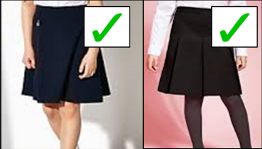

With regards to shoes, please remember that all shoes must be completely black leather, or leather like, with no mesh, material or canvas parts. No trainers of any kind are allowed.

All Parents and Carers must ensure the school uniform policy is followed fully by their child.
This is not an exhaustive list of what is unacceptable at Bristnall Hall Academy. Decisions with reference to uniform will be at the Principal’s discretion.

“We are always accountable for our actions. It is our responsibility to be informed about the requirements of the professional standards by which we measure ourselves”

“Our reputation is our most valuable asset. We earn it every day with the choices we make, and we all share the responsibility to preserve and protect it”

